2025 – Baptism Schedule
Saturday’s at 10am
Month | Day
October | 25

Pre-baptismal Classes
Thursday’s – 7pm – 8:30pm
– Classroom 8

Month | Day
October | 23

Baptismal
Celebration

For Children
Less Than
7 Years of Age

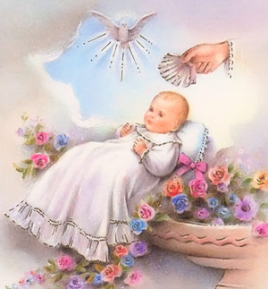

Our Lady of Guadalupe Church
4100 Blue Mound Road
Fort Worth, Texas 76106
817-626-7421

The requirements:

THE PARENTS
- must be registered and active members in the Parish for a minimum of three months and live within our Church boundaries.
- must come to the Church office first to register.
- Paperwork includes: the child’s birth certificate, Single Sponsors 3 Sacrament certificates, or married sponsors Church Marriage certificate along with confirmation for each. Originals Only – No copies or emails unless it is coming Parish to Parish.
- You may register during office hours which are Tue - Fri from 9am -12pm and 1pm – 4:30pm.
- All paperwork must be turned in to the Church office in order to register for a date.
- Pay the registration fee if applicable.
- Attend pre-baptismal class or bring proof of attendance if already taken.

THE SPONSORS
Married Sponsors:
- must be Catholics who are active and practicing their faith.
- must be married by the Catholic Church. They are required to present their Church marriage certificate, not the civil marriage license; no wedding pictures accepted.
Must be Male & Female sponsors.

Single Sponsors:
- each one must be practicing their Catholic faith.
- Single Sponsors means “living alone”; they must be over 18 years of age, and they must present their Sacraments of Baptism, First Communion, and Confirmation certificates. No pictures.
- attend the required class.

Both Parents and Sponsors (Godparents or Padrinos) must attend the class which is held on a Thursday. Please check the schedule. Please be on time. We request that only the Adults attend the class (no children), this way there are less distractions for everyone.

Also, if the Sponsors are receiving Baptismal instructions in another Parish, please bring the verification to our Church office ONE WEEK before the Baptism.

If you cannot attend the Baptism class
or cannot be present at the Baptism ceremony, please contact the Church office.

Anyone wishing to take only the pre-baptismal class should contact the office first.

